**Part I**

1. **Information Architecture for the new Paradigm Pet Professionals Website:**
2. The **necessary** website **functionality needs** and **micro interaction needs:**
   1. **Audience Needs**

The audience needs to be able to easily identify available information according to their pet. What ever animal they are looking for should be easy and straightforward for them to find.

* 1. **Stakeholder Needs**

Site must have consistent branding, be easy to navigate, and be able to schedule 150 consultations. Throughout the site, the branding for the company should be consistent and the site should be easily navigable. Additionally, stakeholders should be able to get various information from potential costumer to schedule a consultation.

1. Describe the **Type of content** used for:
   1. **One** **new page** based on **One** of the new user persona

The bird page will have instruction/information of the general care for pet birds. This will address any specific concerns a bird owner may have ranging from their diet, size and mental condition. Bird owners will be able to learn how to respond to depression in their bird and what signs to look for from the site page.

3.  Identify existing content from the website that will be removed or redeveloped then

**explain** how **that content fails to meet:**

The FAQ page will be removed because all information will be provided on the content page for each animal, allowing more simplicity for users. The stakeholder needs for there to be basic advice for many common pets. The pet information will be redeveloped to incorporate more common pets than just cats and dogs.

4.  **Create a visual sitemap** to determine the structure and the hierarchy of the site content, including the following:

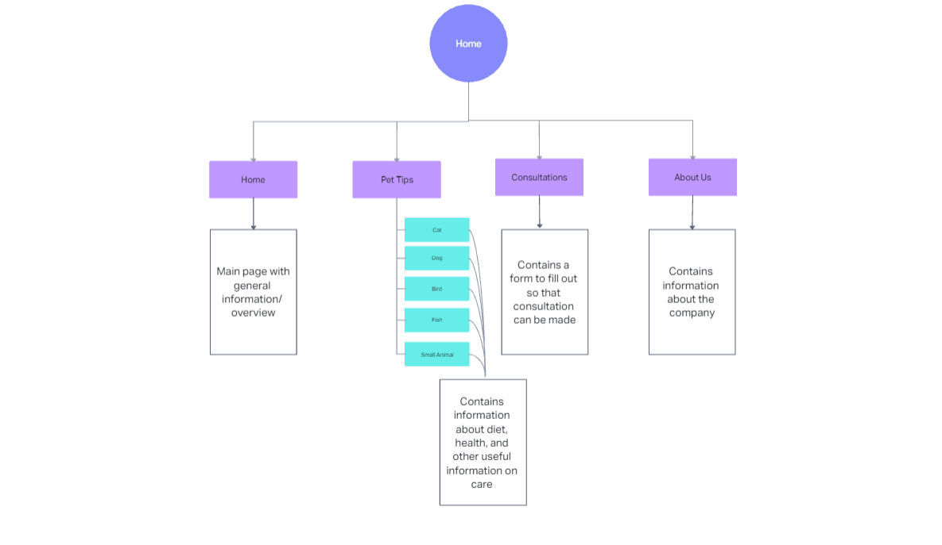

### 

5 **Explain how your information architecture meets both:**

* The content provided for each pet will give users knowledge about how to care for their pet in many aspects. The readability of each page will allow users to clearly understand information about feeding, housing, and maintaining the health of their pet.
* The submission form page allows stakeholders to schedule new consultations. Each field will give a short description of what should be provided. This will let users give accurate information for stakeholders to use.

**6.  Explain the (1) primary and the (2) secondary navigational elements required to support the information architecture.**

The primary navigation will include:

* Home
* Pet tips
* Consultations

This will give the user an easy primary navigation bar so they can easily change through the various pages of information.

The secondary navigation will include (under “Pet Tips”):

* Cat
* Dog
* Bird

These will show as a dropdown menu under the “Pet Tips”

* **Then explain how the primary and secondary navigational elements each align with the:**

The Audience needs will be met in the primary elements because they will be able to navigate through each page easily and quickly. The secondary page allows users to go straight to their pet’s page to find information they are looking for.

The Stakeholder's needs will be met through the primary navigation as the consultations page will be accessed through there. The secondary navigation provides the easy and basic search for all users because when they need will be listed out simply and clearly.

1. **Determine page layout by creating a mid-fidelity wireframe for the home page that is sized for a desktop website that includes each of the following:**

